# Introduction

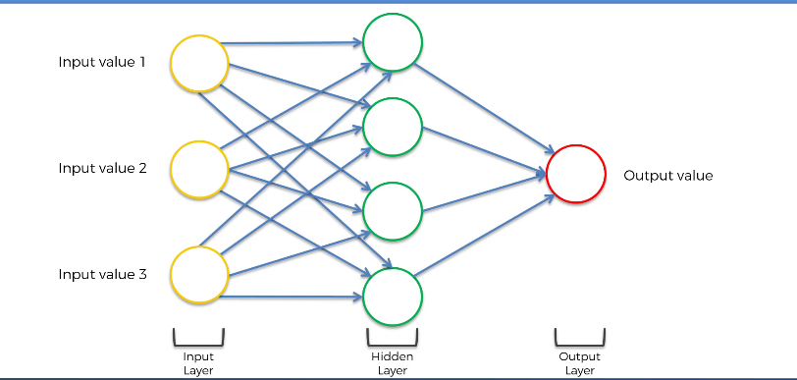

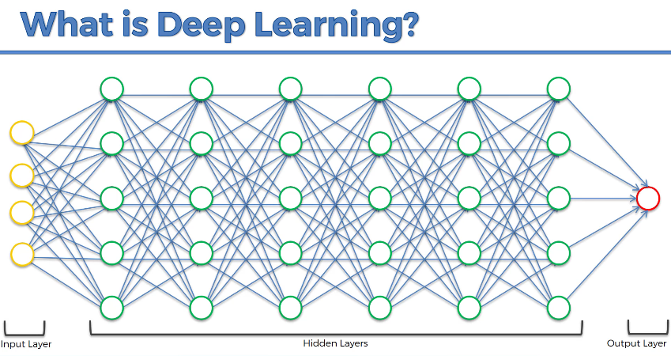

# Codes and Datasets

<https://www.superdatascience.com/deep-learning>

# Plan

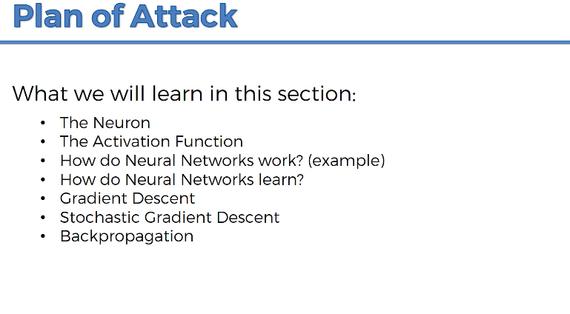

# Neurons

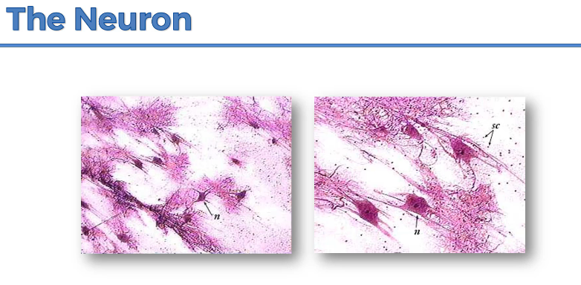

Neurons in human mind.

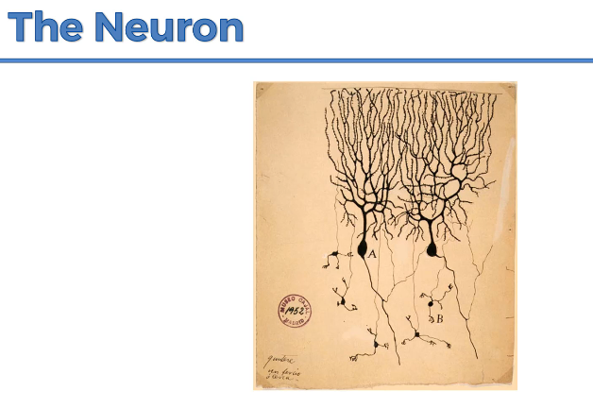

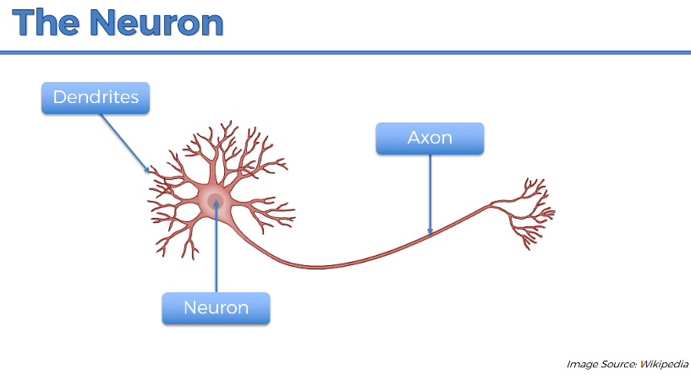

Dendrites – receivers of the signals

Axon – transmitter of the signals

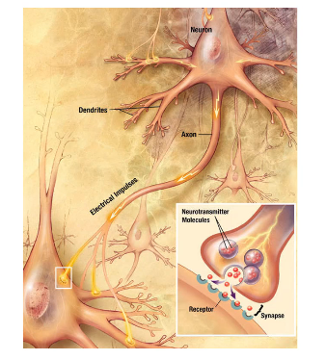

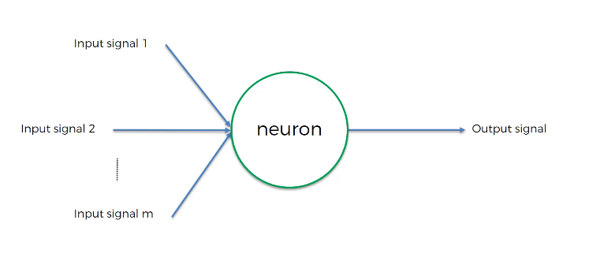

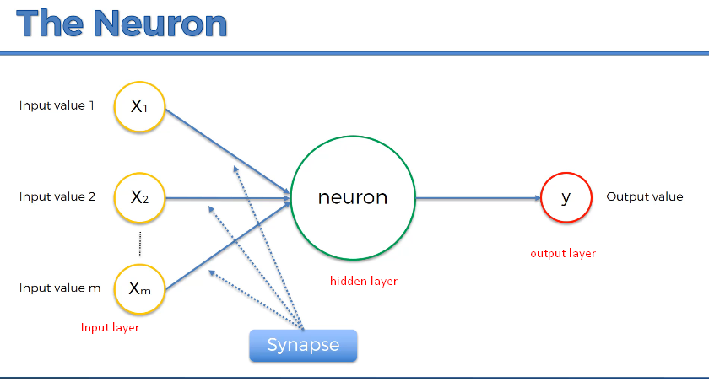

In case of humans, input neurons are like 5 senses.

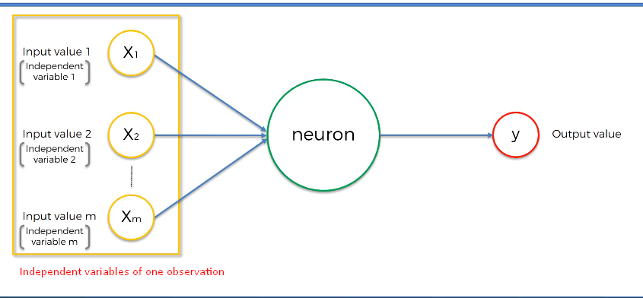

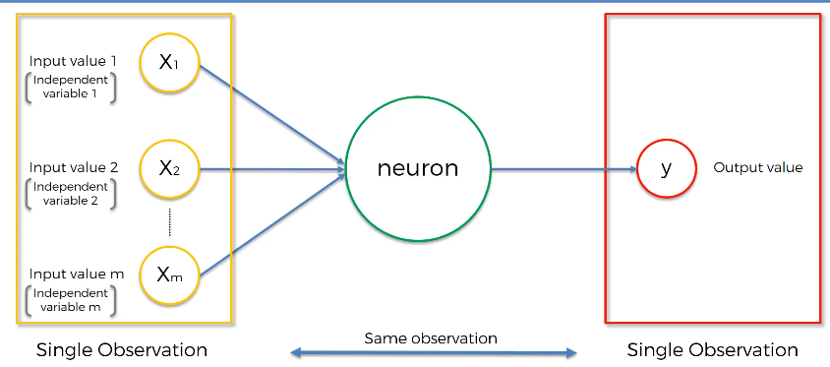

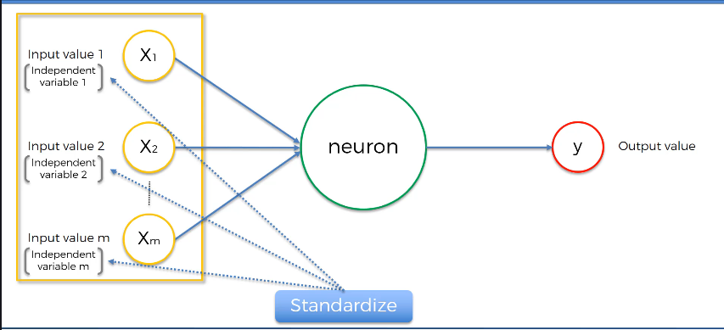

Normalization and Standardization

<https://www.youtube.com/watch?v=bqhQ2LWBheQ&t=84s>

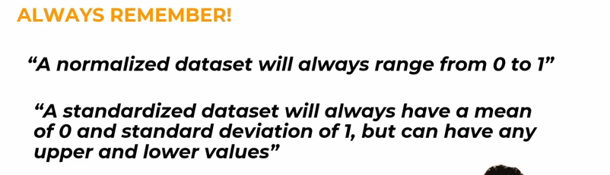

Standardization is also called Z-score Normalization.

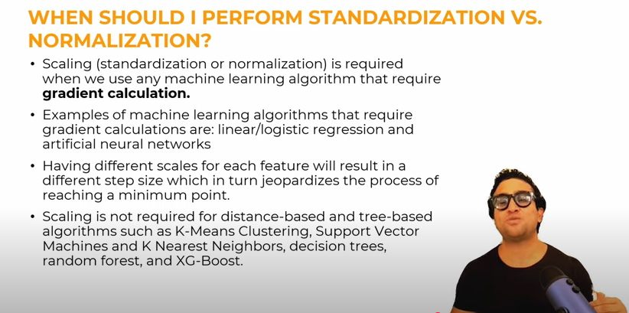

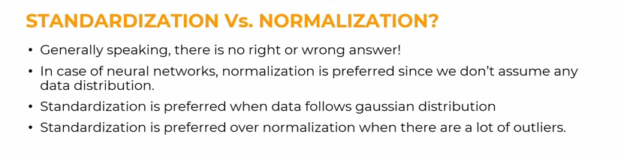

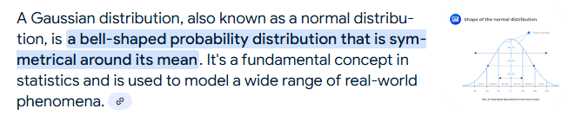

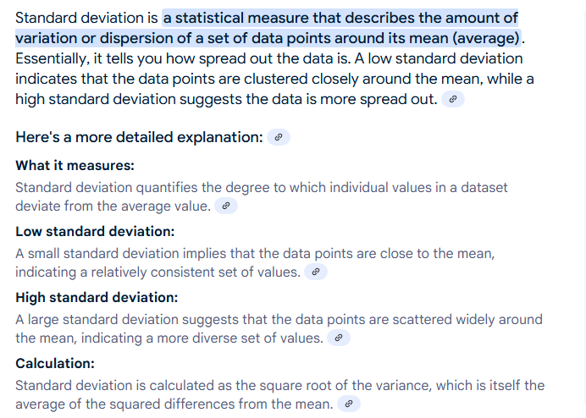

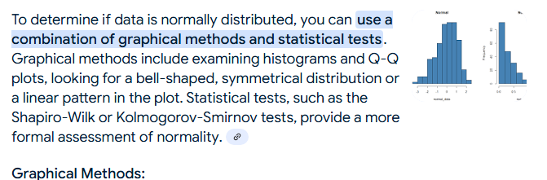

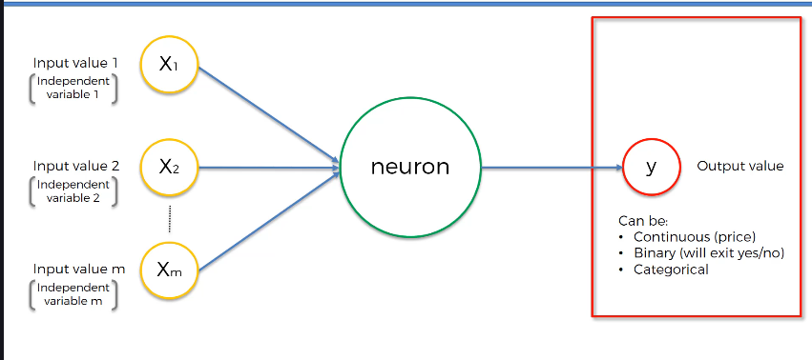

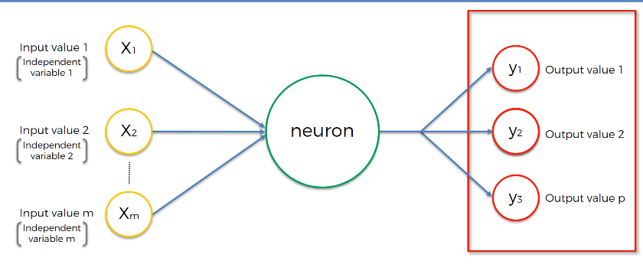

In case of categorical output, you need multiple output neurons (one for each category).

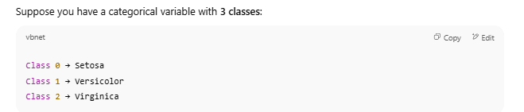

If you only had **1 output neuron**, it couldn’t distinguish among **3+ classes** — it can only give a yes/no signal.

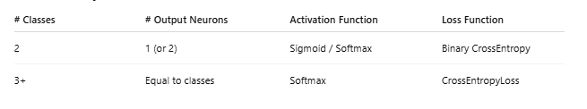

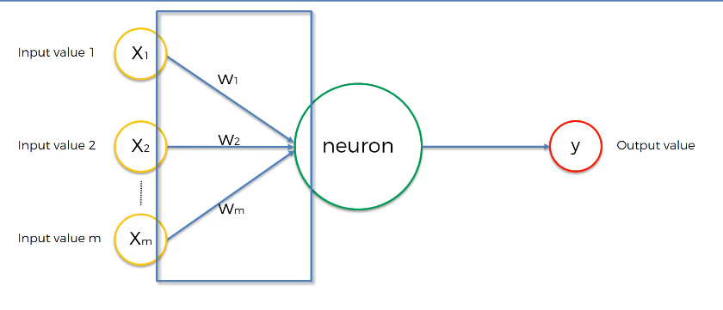

Weights get adjusted during the process of training the Neural Network. That is when Gradient Descent and Back Propagation come into play.

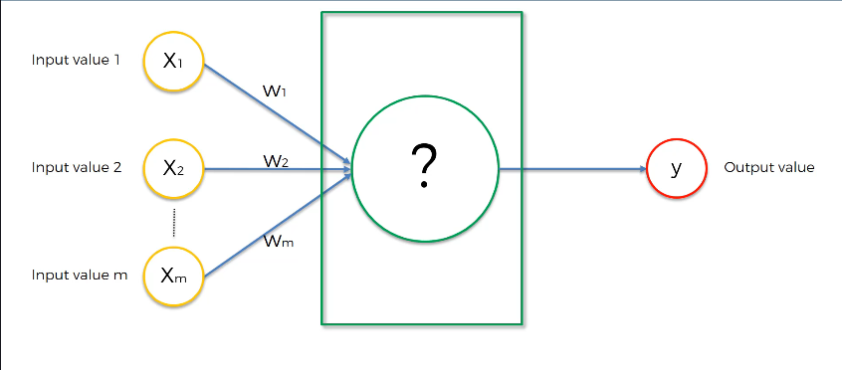

What happens in the neuron?

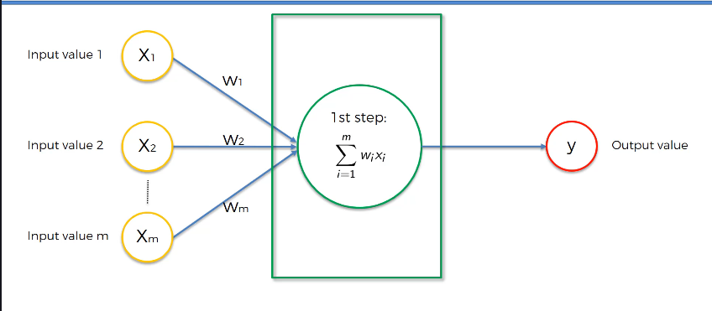

First step is to just do x1w1+x2w2+…..+xmwm

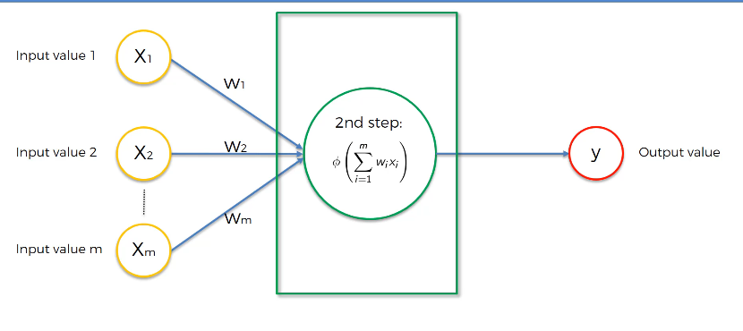

Second step is to apply Activation Function.

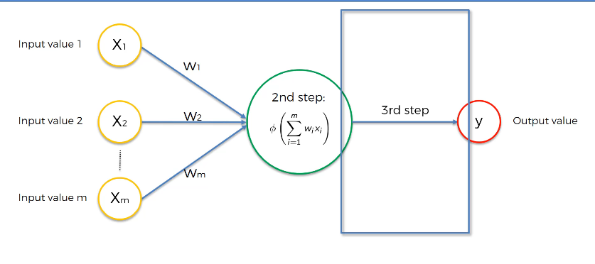

Third step is passing the data to the next neuron down the line.

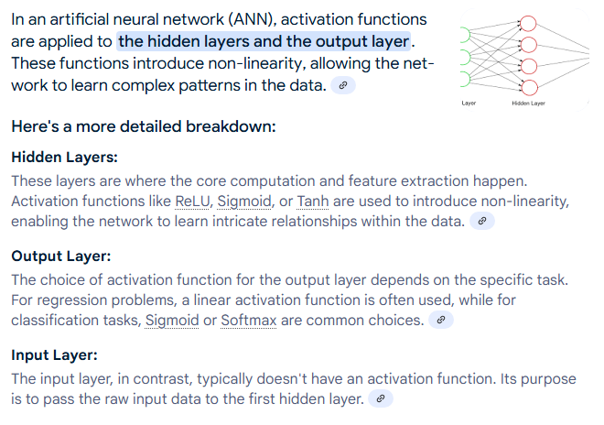

# Activation Function

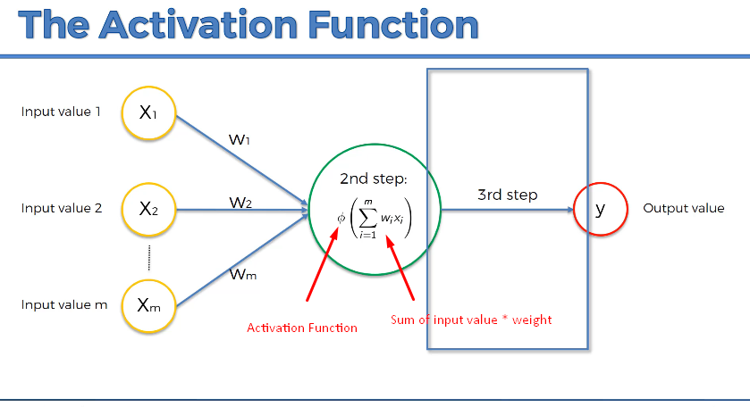

Activation function is applied on hidden layers and output layer.

## Threshold Function

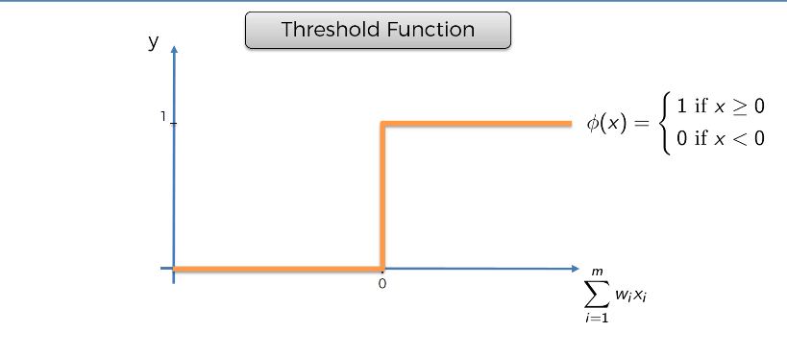

If  is <0, threshold function returns 0, otherwise it returns 1. There is no in between value.

## Sigmoid Function

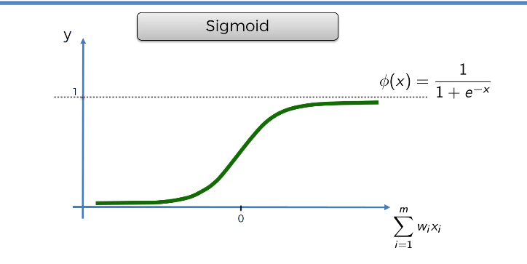

Sigmoid function . This function is also used in Logistic Regression. It is very useful for output layer. It returns any value in between 0 and 1. Unlike to Threshold Function, it is not exactly 0 or 1. If it is close to 0, it is considered 0. If it is close to 1, it is considered 1.

## Hyperbolic Tangent (tanh) Function

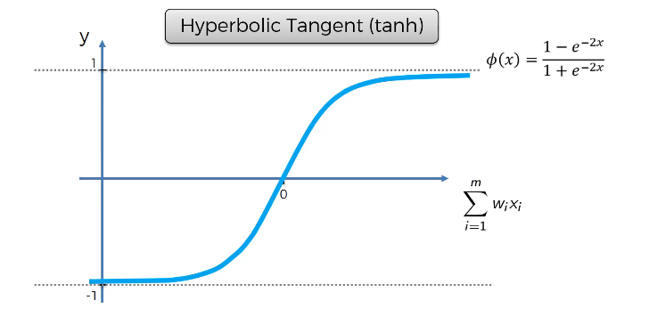

It is very much similar to Sigmoid Function. Instead of 0 to 1, it goes from -1 to 1. It is zero-centered.

## ReLU (Rectified Linear Unit) Function

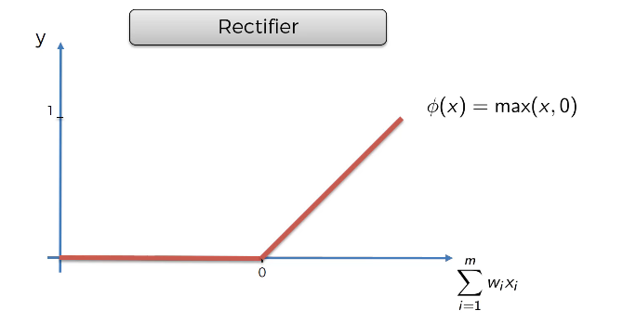

Rectifier function. It is one of the most used and important Activation Function.

## Leaky ReLU (Parametric ReLU)

From Neural Network.docx document

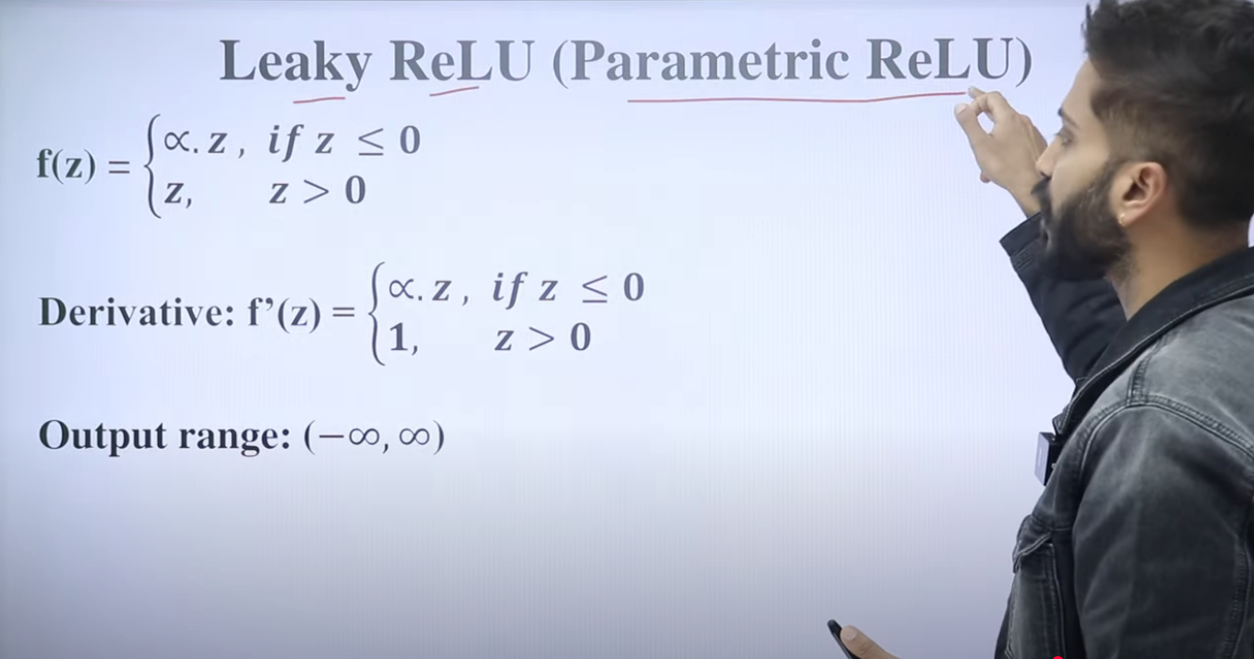

 is a very small positive constant like 0.01, 0.02.

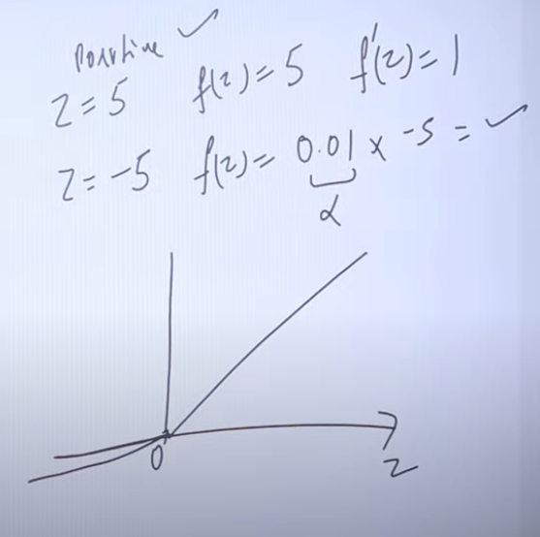

## More Information

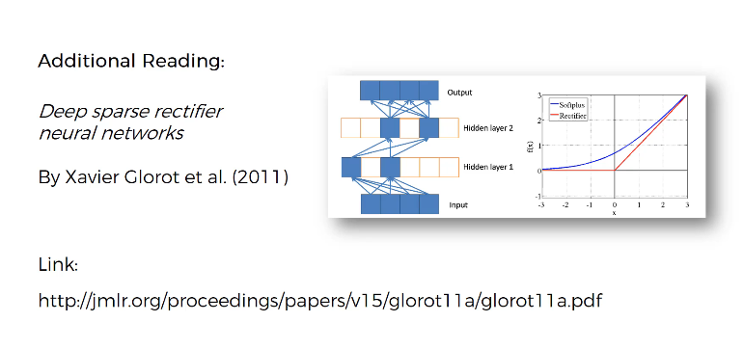

## Which Activation Function to use?

If Dependent Variable is binary, 0 or 1, which activation function would you use.

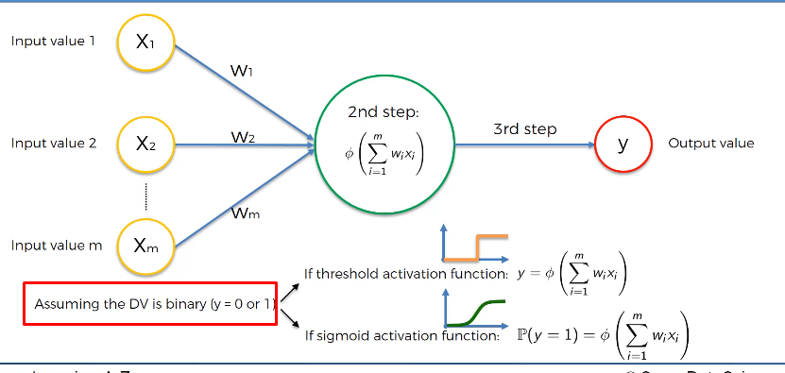

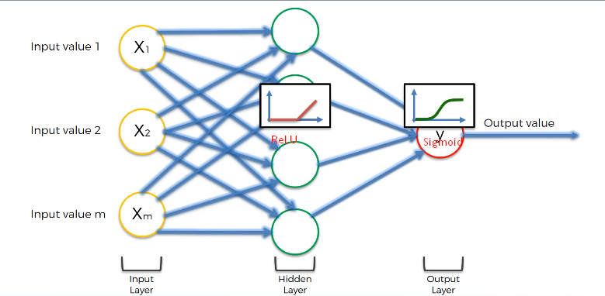

# How do NNs work?

## Step-by-Step Guide to Property Valuation Example

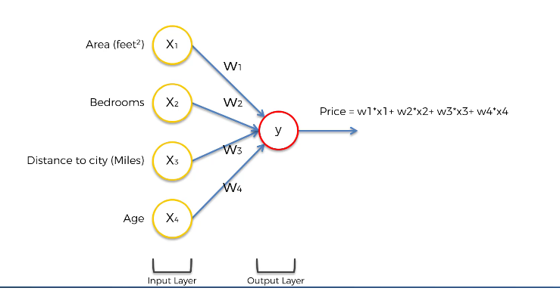

This is the simplest form of NN.

Hidden layer gives us the extra power.

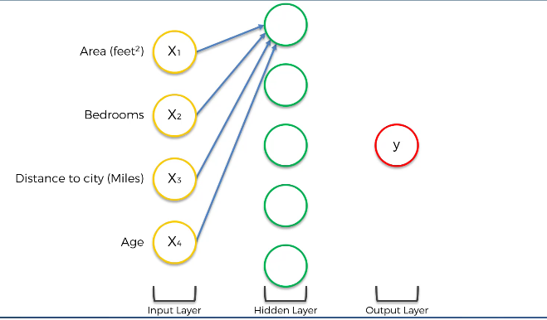

For this neuron, Area and Distance to city are important, so they will have non-zero weights, whereas Bedrooms and Age will have zero weights.

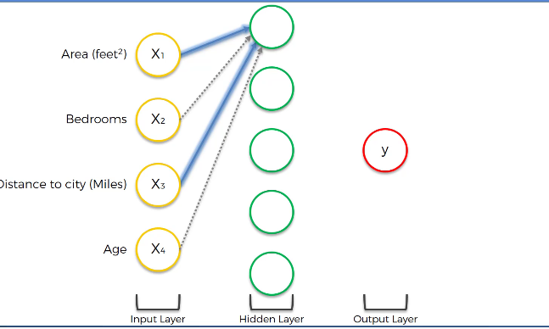

This particular neuron is looking for the houses which are not so far from the city and have large areas.

Let’s just get rid of lines having zero weights.

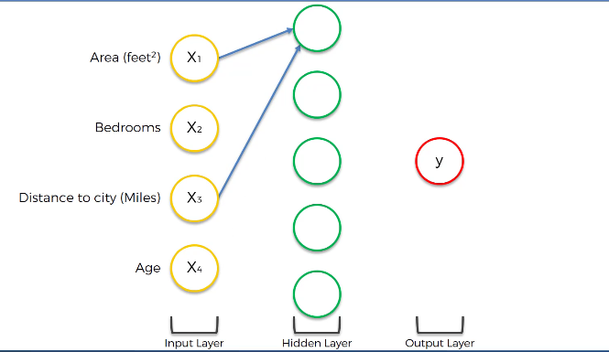

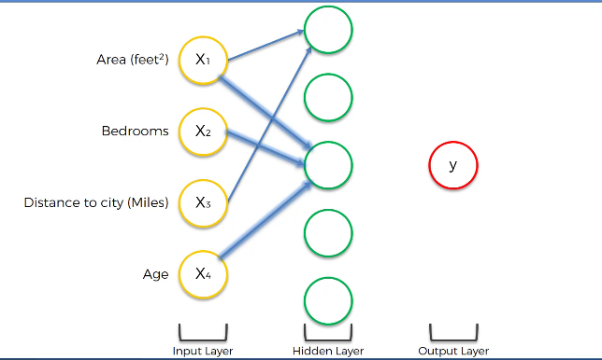

This neuron is interested in Area, Bedrooms and the Age of the property (house). There are people looking for new and large house with many rooms. They are not interested in how far it is from the city.

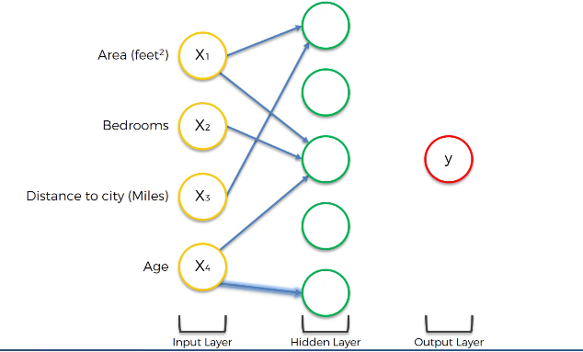

This neuron can pick up the properties which are very old (> 100 years) and historical. There are people who are interested in these kind of properties. ReLU activation function is perfectly suitable for this neuron. Till 100 years of age, it returns 0 and then it returns higher value as age of the property increases.

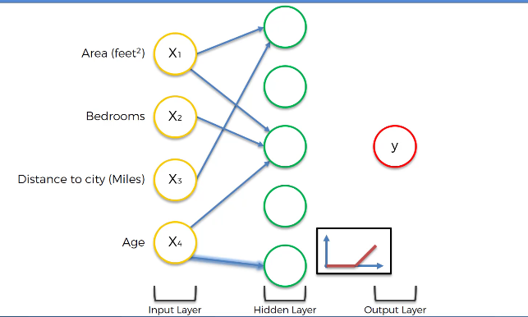

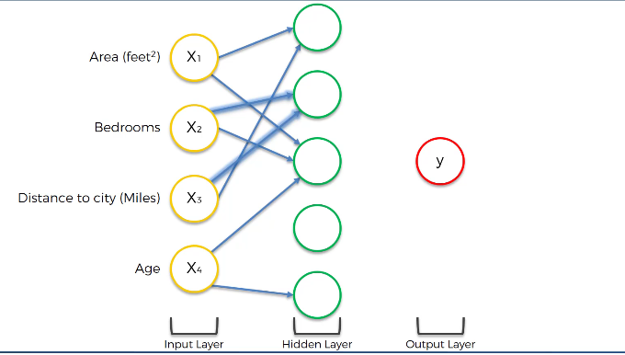

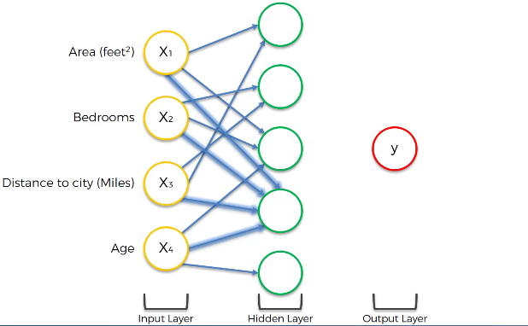

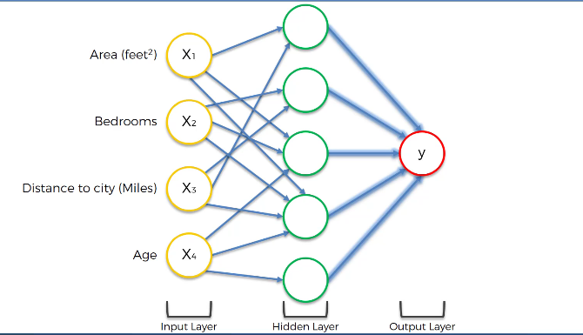

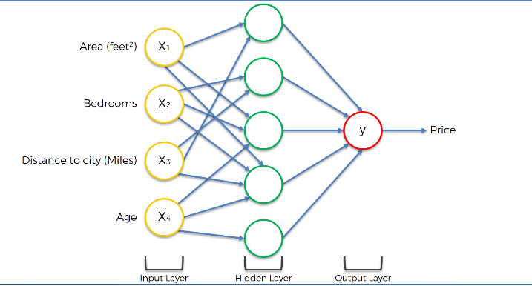

# How do NNS Learn?

## Understanding Backpropagation and Cost Functions